**Day 28 Home questions**

#1. WAP to display the reverse of a number entered through keyboard.

Code:

#include <stdio.h>

int main()

{

    int i285,rem285,n285,div285;

    printf("Please provide the number you want to be reversed=>");

    scanf("%d",&n285);

    for(i285=1;i285<=n285;n285=n285/10)

    {

        rem285=n285%10;

        printf("%d",rem285);

    }

    return 0;

}

Output:

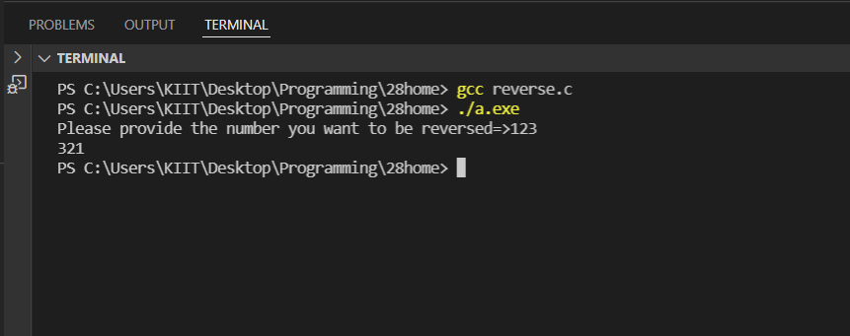

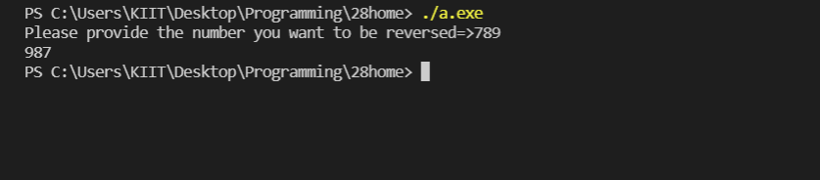

#2. WAP to check whether an integer number is a Armstrong number or not!.

Code:

#include <stdio.h>

#include <math.h>

int main()

{

    int i285,sum285,n285,rem285,globe285,j285,dummy285;

    printf("Please provide a number to check if it is armstrong=>");

    scanf("%d",&n285);

    globe285=n285;

    for(i285=1;i285<=n285;n285=n285/10)

    {

        rem285=n285%10;

        sum285= sum285 + pow(rem285,3);

        if(sum285==globe285)

        {

            dummy285=1;

            printf("yes %d is an armstrong number!\n",globe285);

        }

    }

    if(dummy285!=1)

    {

        printf("%d is not an armstrong number",globe285);

    }

    return 0;

}

Output:

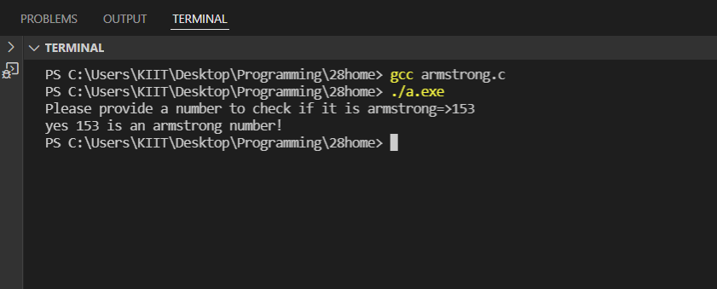

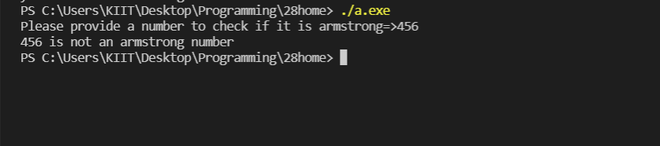

#3. WAP to print the following pattern for n rows. Ex. for n=5 rows

A

B A

C B A

D C B A

E D C B A

Code:

#include<stdio.h>

void main()

{

    int i285,j285,n285;

    printf("\nEnter the number of lines\n");

    scanf("%d",&n285);

    for(i285=1;i285<=n285;i285++)

    {

        for(j285=i285;j285>=1;j285--)

        {

            printf("%c ",(char)(j285+64));

        }

        printf("\n");

    }

}

Output:

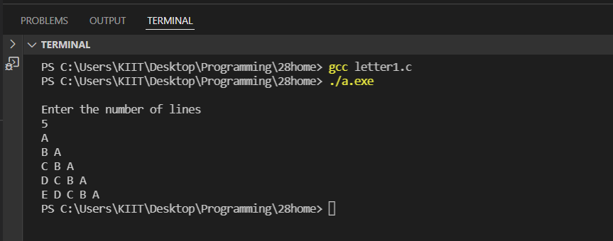

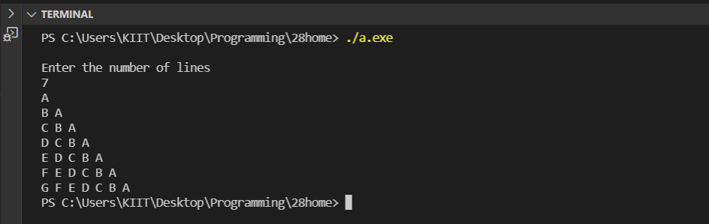

#4. WAP to print the following pattern for n rows. Ex. for n=5 rows

1

2 1

1 2 3

4 3 2 1

1 2 3 4 5

Code:

#include <stdio.h>

int main()

{

int i285, j285, N285;

printf("\nEnter rows: ");

scanf("%d", &N285);

for(i285=1; i285<=N285; i285++)

{

    if(i285 & 1)

    {

        for(j285=1; j285<=i285; j285++)

        {printf("%d ", j285);}

    }

    else

    {

        for(j285=i285; j285>=1; j285--)

        {printf("%d ", j285);}

    }

printf("\n");

}

return 0;

}

Output:

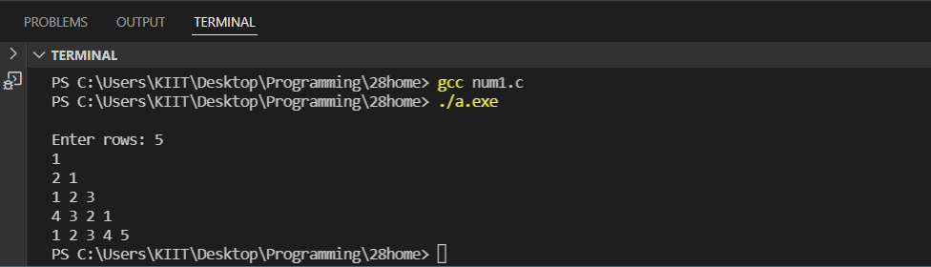

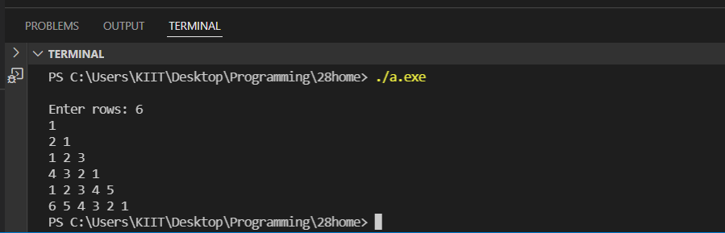

#5. WAP to form reverse pyramid of numbers for a given number. Ex. for

number 4

1 2 3 4 3 2 1

1 2 3 2 1

1 2 1

1

Code:

#include <stdio.h>

int main()

{

int i285,j285,rows285,space285=0;

printf("\nEnter the number of rows:");

scanf("%d",&rows285);

for(i285=rows285; i285>=1; i285--)

{

    for(j285=1; j285<=space285; j285++)

        printf("   ");

    for(j285=1; j285<=i285; j285++)

        printf(" %d ",j285);

    for(j285=i285-1; j285>=1; j285--)

        printf(" %d ",j285);

    printf("\n");

    space285++;

}

return 0;

}

Output:

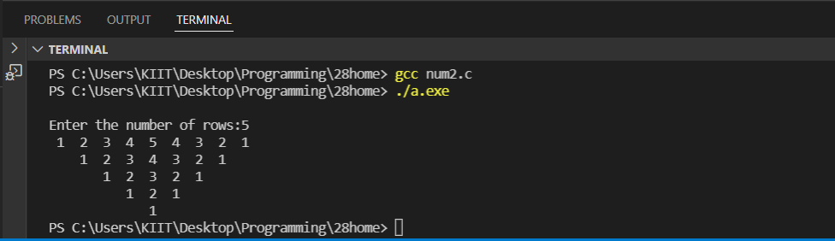

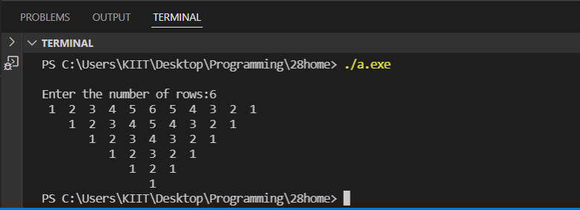

#6. WAP to print the following pattern for n rows. Ex. for n=6 rows

0

1 0

0 1 0

1 0 1 0

0 1 0 1 0

1 0 1 0 1 0

Code:

#include <stdio.h>

int main()

{

int i285,j285,rows285;

int num285=1;

printf("\nEnter the number of rows: ");

scanf("%d",&rows285 );

for(i285=1; i285<=rows285; i285++)

{

    for(j285=1; j285<=i285; j285++)

    {

        printf(" %d ",num285);

        num285=!num285;

    }

    num285=i285%2;

    printf("\n");

}

    return 0;

}

Output:

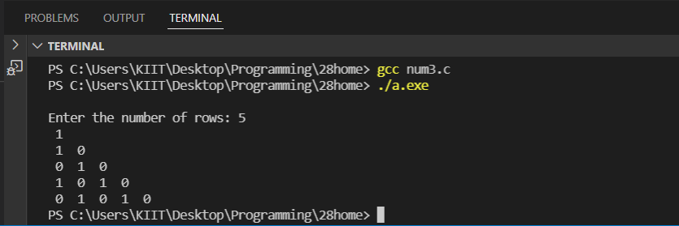

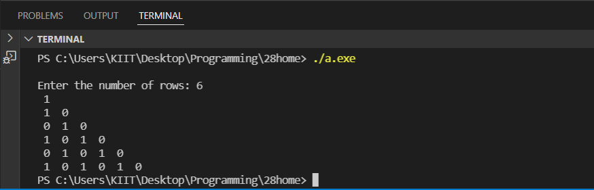

#7. WAP to generate the pascal triangle pyramid of numbers for a given

number.

Ex. for number 4

1

1 1

1 2 1

1 3 3 1

1 4 6 4 1

Code:

#include <stdio.h>

int main()

{

int rows285, coef285 = 1, space285, i285, j285;

printf("\nEnter the number of rows: ");

scanf("%d", &rows285);

for (i285 = 0; i285 < rows285 +1; i285++)

{

    for (space285 = 1; space285 <= rows285 - i285; space285++)

        printf("  ");

    for (j285 = 0; j285 <= i285; j285++)

    {

        if (j285 == 0 || i285 == 0)

        coef285 = 1;

        else

        coef285 = coef285 * (i285 - j285 + 1) / j285;

        printf("%4d", coef285);

    }

    printf("\n");

}

return 0;

}

Output:

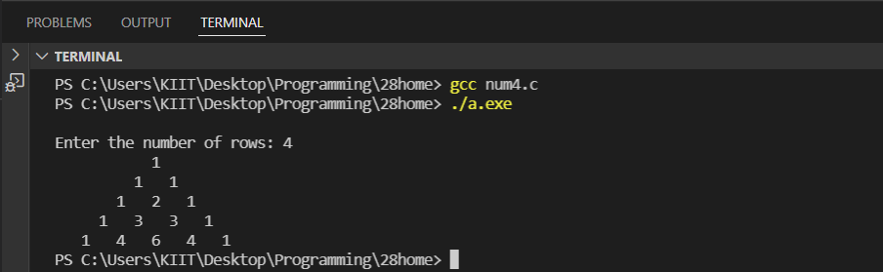

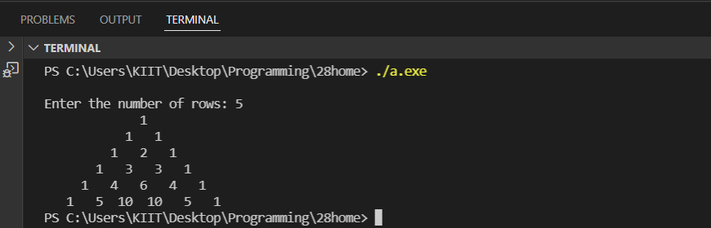

#8. WAP to display the following style o/p for a given string input through

keyboard.(Ex.for a string “KIITCSIT”)

KIITCSITTISCTIIK

KIITCSI ISCTIIK

KIITCS SCTIIK

KIITC CTIIK

KIIT TIIK

KII IIK

KI IK

K K

KI IK

KII IIK

KIIT TIIK

KIITC CTIIK

KIITCS SCTIIK

KIITCSI ISCTIIK

KIITCSITTISCTIIK

Code:

#9. WAP to convert a decimal number into its equivalent binary number.

Code:

#include <stdio.h>

#include <math.h>

long long convert(int);

int main() {

  int n285, bin285;

  printf("Enter a decimal number: ");

  scanf("%d", &n285);

  bin285 = convert(n285);

  printf("%d in decimal =  %lld in binary", n285, bin285);

  return 0;

}

long long convert(int n285) {

  long long bin285 = 0;

  int rem285, i285 = 1;

  while (n285!=0) {

    rem285 = n285 % 2;

    n285 /= 2;

    bin285 += rem285 * i285;

    i285 *= 10;

  }

  return bin285;

}

Output:

